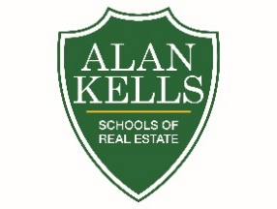
ALAN KELLS SCHOOLS OF REAL ESTATE

119 GAMMA DRIVE

PITTSBURGH, PA 15238

COACHING COURSE REGISTRATION FORM

DATES: August 24, 25 and 26, 2021

LOCATION: VIRTUAL

TIME: 6:00PM – 9:00PM FEE: $45.00

NAME:
First Last

ADDRESS:
Street Address City State Zip

PHONE:
Home Work

EMAIL ADDRESS:

How did you hear about the coaching course?

- Pre-registration and Pre-payment are required to secure your seat in the class.
- You will need Zoom Client software

To register for Coaching Course:

Email: alankellsinfo@alankells.com

Mailing Address: Alan Kells Schools of Real Estate
119 Gamma Drive
Pittsburgh, PA 15238

- Registration confirmation email will be sent to your email address.
- You will receive an invitation to join Zoom session.
- Payments are accepted by Check, Master Card or Visa (Do not accept Amex or Discover). Checks are payable to Alan Kells Schools of Real Estate

Payment:
MasterCard / Visa Account Number: ______________________________Exp. Date: ______
Signature_________________________________

